MODULE 1- JAVASCRIPT
PROJECT THEME: LOCAL COMMUNITY EVENT PORTAL

NAME: SHUBHASHREE M
SUPERSET ID: 6742954

TASK 1: JAVASCRIPT BASICS & SETUP
CODE:
Index.html
<!DOCTYPE html>
<html>
<head>
<title>Community Portal</title>
</head>
<body>
<h1>Community Event Portal</h1>
<script src="main.js"></script>
</body>
</html>
Main.js:
console.log("Welcome to the Community Portal");

window. onload = function () {
alert("Page Fully Loaded");
};

OUTPUT:
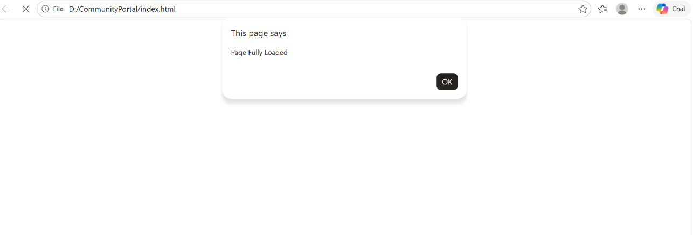
TASK 2 : SYNTAX, DATA TYPES AND OPERATORS
CODE:
Main.js
const eventName = "Music Fest";
const eventDate = "10 June 2026";
let seats = 50;
console.log(`Event: ${eventName}
Date: ${eventDate}
Seats Available: ${seats}`);
seats++;
console.log("Updated Seats:", seats);

OUTPUT:
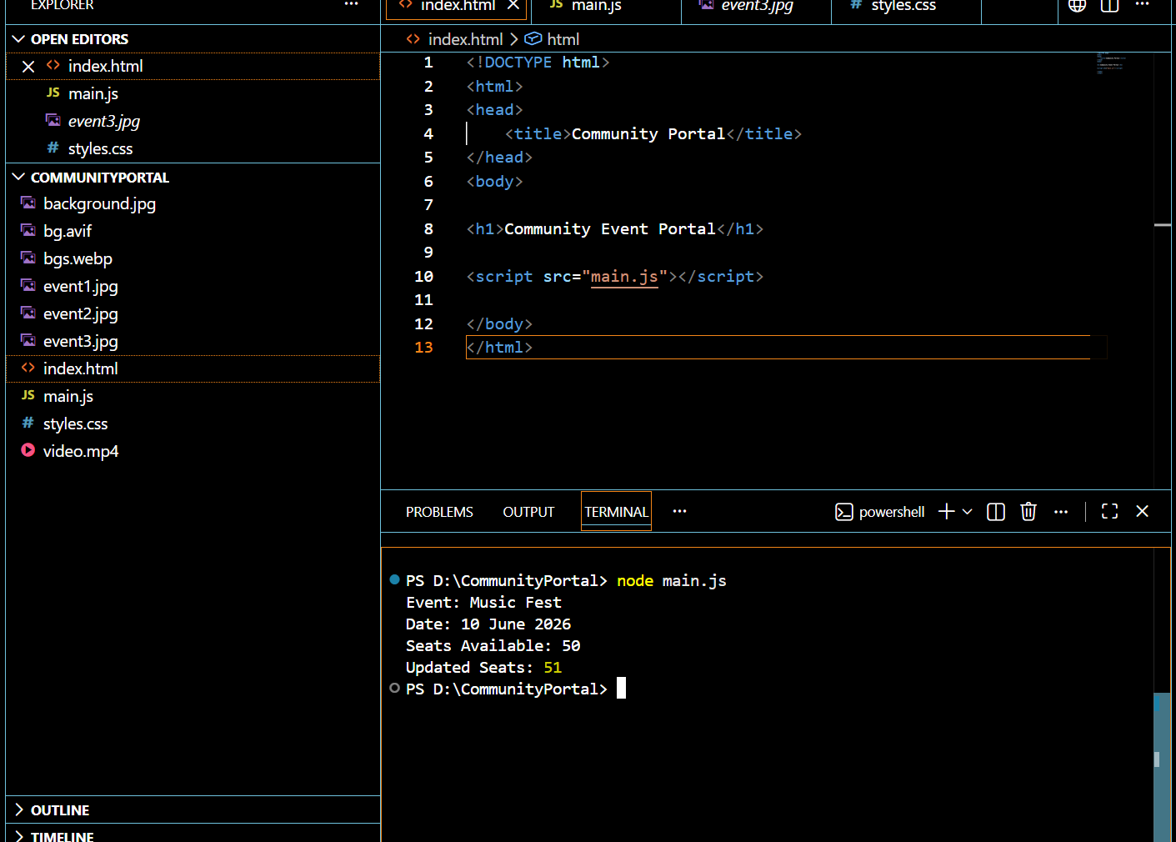

TASK 3: CONDITIONALS, LOOPS AND ERROR HANDLING
CODE:
const events = [
{name:"Music Show", seats:20, upcoming:true},
{name:"Old Event", seats:0, upcoming:false},
{name:"Dance Fest", seats:10, upcoming:true}];
events.forEach(event => {
if(event.upcoming && event.seats > 0){
console.log(event.name); }
else{
console.log(event.name + " Hidden"); }
});
try{
let seats = 0;
if(seats <= 0){
throw "Registration Closed"; }
}
catch(error){
console.log(error);}
OUTPUT:

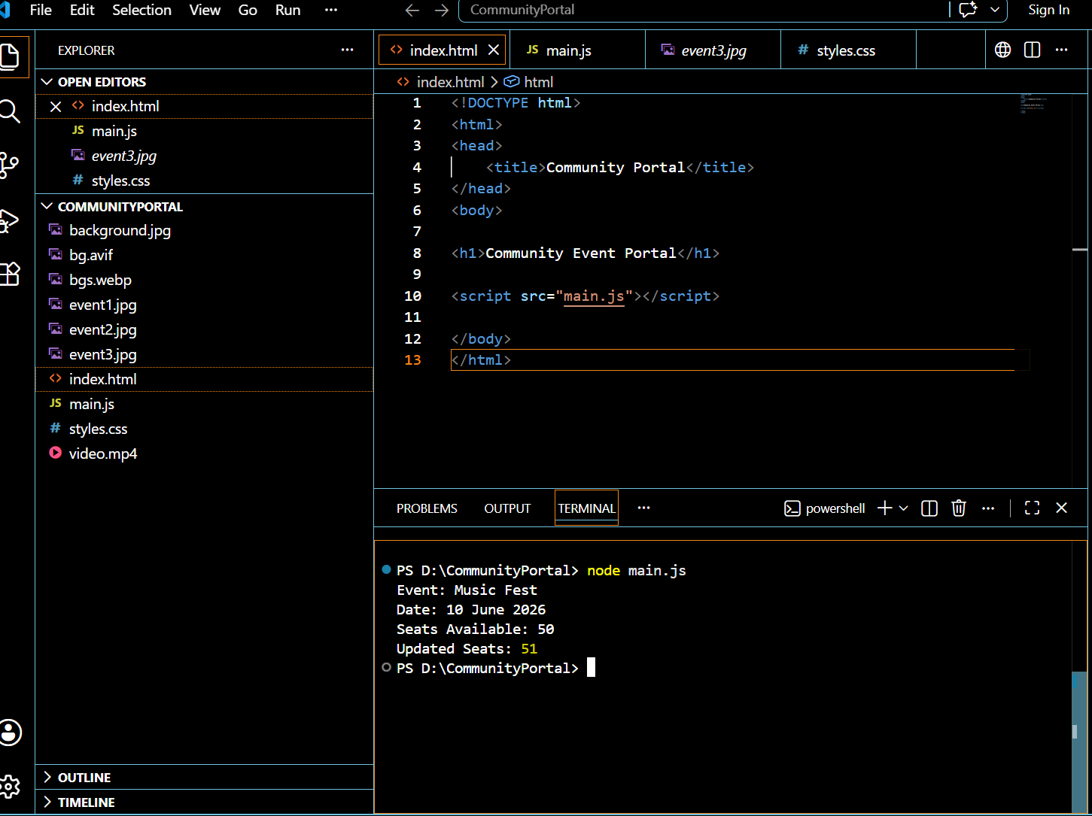

TASK 4: FUNCTIONS, SCOPE, CLOSURES, HIGHER ORDER FUNCTIONS
CODE:
function addEvent(name){
console.log(name + " Added");}
function registerUser(user){
console.log(user + " Registered");}
function filterEventsByCategory(events, callback){
return events.filter(callback);}
function registrationCounter(){
let count = 0;
return function(){
count++;
return count; };
}
const counter = registrationCounter();
console.log(counter());
console.log(counter());
const data = ["Music","Sports","Music"];
const result = filterEventsByCategory(
data,
item => item === "Music");
console.log(result);
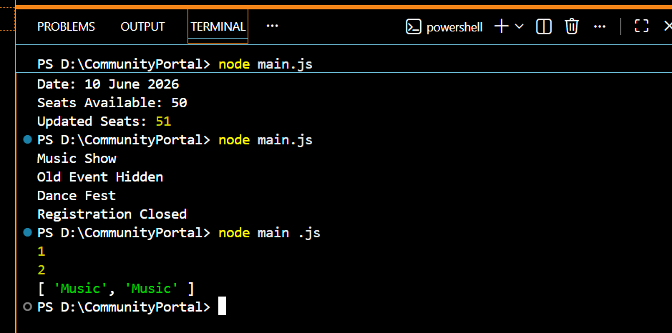
OUTPUT:
TASK 5: OBJECTS AND PROTOTYPES
CODE:
class Event{
constructor(name,seats){
this.name = name;
this.seats = seats;}
}
Event.prototype.checkAvailability = function(){
return this.seats > 0;
};
const e1 = new Event("Workshop",30);
console.log(e1.checkAvailability());
Object.entries(e1).forEach(([key,value])=>{
console.log(key,value);
});

OUTPUT:
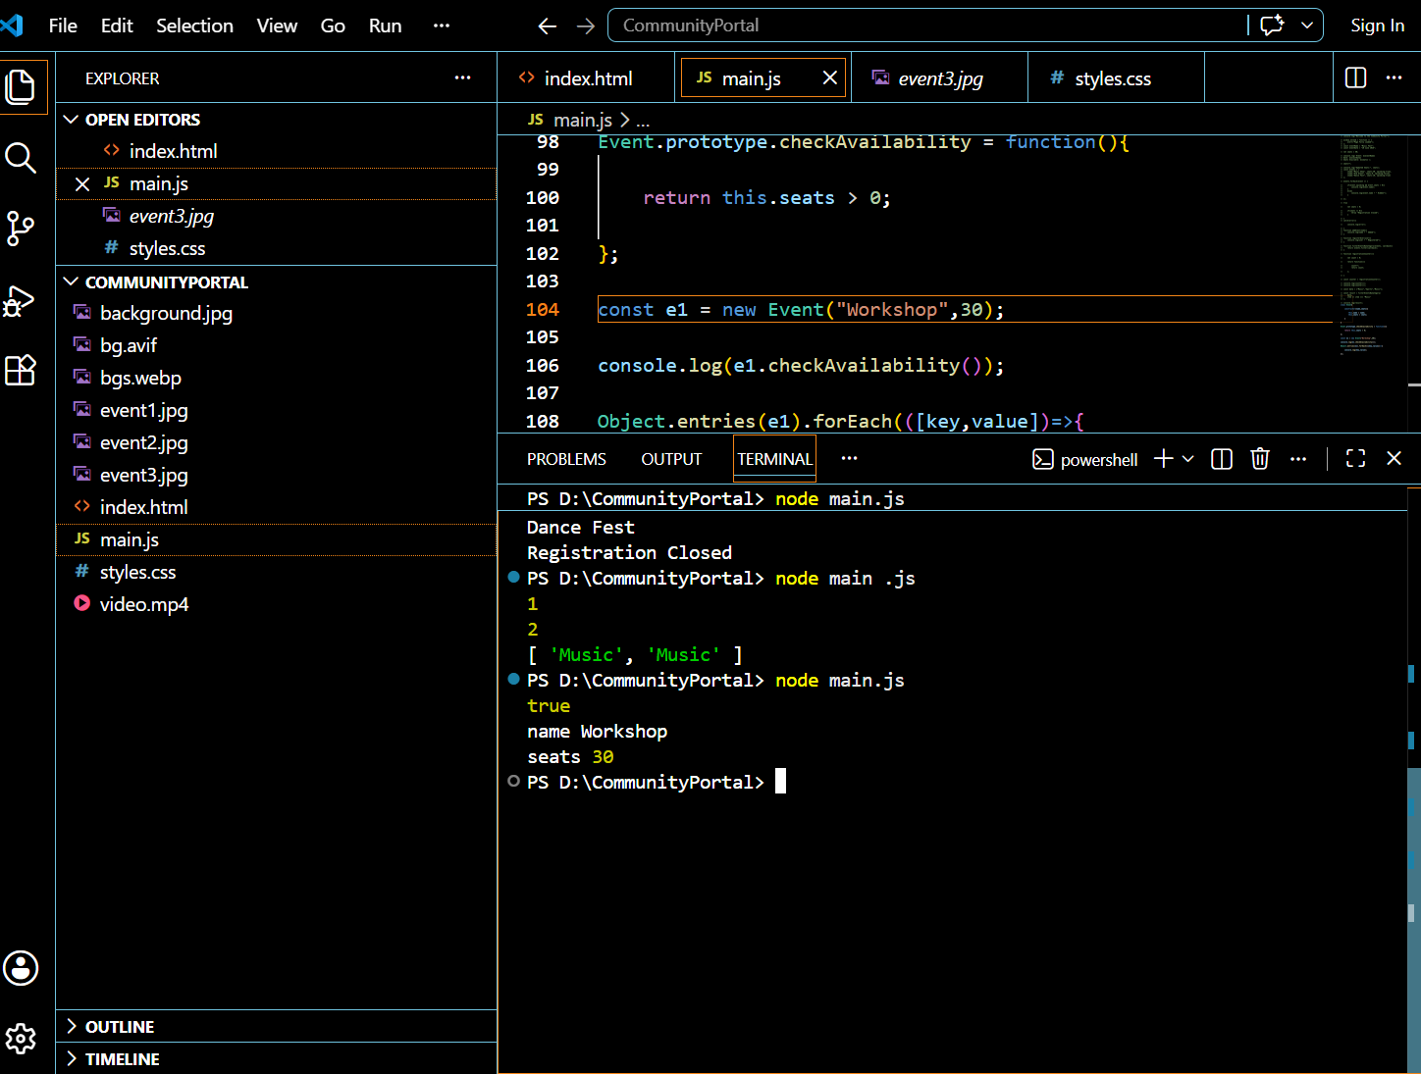

TASK 6: ARRAYS AND METHODS
CODE:
let events =
{ name: "Music Night", category: "Music" },
{ name: "Baking Workshop", category: "Workshop" },
{ name: "Dance Show", category: "Music" }
];
events.push({
name: "Coding Event",
category: "Tech"
});
console.log("All Events:");
console.log(events);
let musicEvents = events.filter(
event => event.category === "Music"
);
console.log("Music Events:");
console.log(musicEvents);
let formattedEvents = events.map(
event => "Workshop on " + event.name
);
console.log("Formatted Events:");
console.log(formattedEvents);
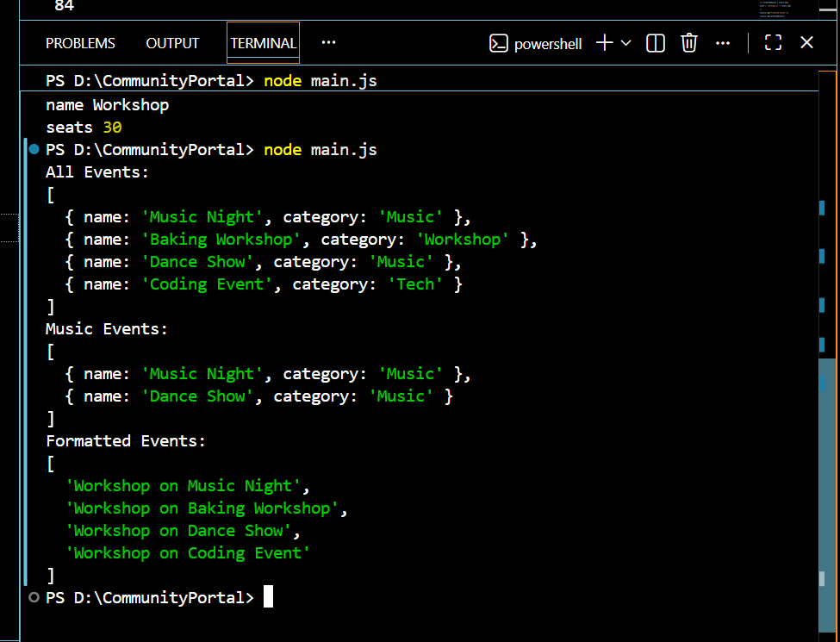
OUTPUT:
TASK 7: DOM MANIPULATION
CODE:
const events = [
{ name:"Music Night", seats:5 },
{ name:"Coding Workshop", seats:3 },
{ name:"Dance Show", seats:2
];
const container = document.querySelector("#eventContainer");
events.forEach(event => {
let card = document.createElement("div");
card.className = "card";
card.innerHTML = `
<h3>${event.name}</h3>
<p>Seats Left: <span>${event.seats}</span></p>
<button>Register</button>
<button>Cancel</button>`;
const registerBtn = card.children[2];
const cancelBtn = card.children[3];
const seatText = card.querySelector("span");
registerBtn.onclick = function(){
if(event.seats > 0){
event.seats--;
seatText.textContent = event.seats;}};
cancelBtn.onclick = function(){
event.seats++;
seatText.textContent = event.seats;
};
container.appendChild(card);});

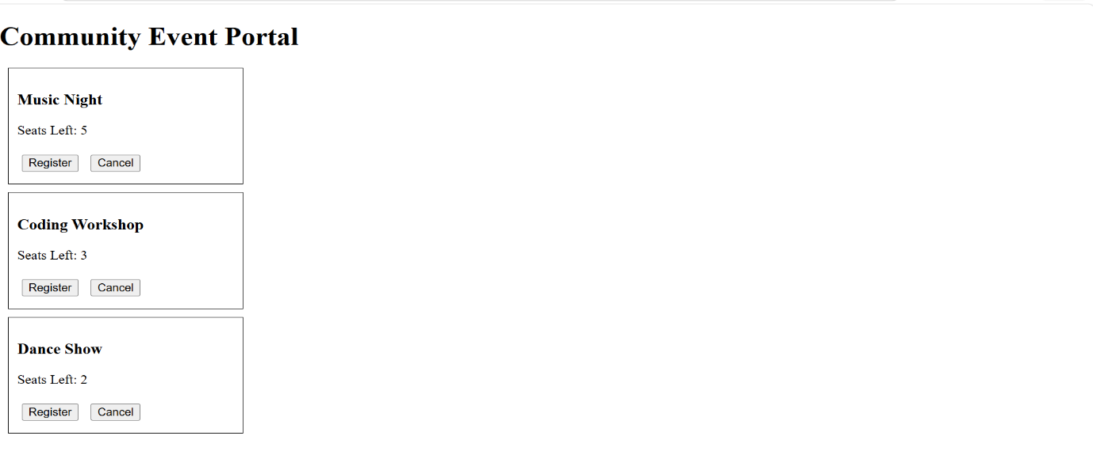
OUTPUT:

TASK 8: EVENT HANDLING
CODE:
const events = [
{ name:"Music Night", category:"Music", seats:5 },
{ name:"Coding Workshop", category:"Workshop", seats:3 },
{ name:"Dance Music Fest", category:"Music", seats:2 }];
const container = document.querySelector("#eventContainer");
const filterBox = document.querySelector("#categoryFilter");
const searchBox = document.querySelector("#searchBox");
function displayEvents(data){
container.innerHTML = "";
data.forEach(event => {
let card = document.createElement("div");
card.className = "card";
card.innerHTML = `
<h3>${event.name}</h3>
<p>Category: ${event.category}</p>
<p>Seats: <span>${event.seats}</span></p>
<button>Register</button>
`;

const btn = card.querySelector("button");
const seatText = card.querySelector("span");
btn.onclick = function(){
if(event.seats > 0){
event.seats--;
seatText.textContent = event.seats;}};
container.appendChild(card);});}
displayEvents(events);
filterBox.onchange = function(){
const value = filterBox.value;
const filtered = events.filter(event =>
value === "All" || event.category === value
);
displayEvents(filtered);
};
searchBox.onkeydown = function(){
const search = searchBox.value.toLowerCase();
const result = events.filter(event =>
event.name.toLowerCase().includes(search)
);
displayEvents(result);
};
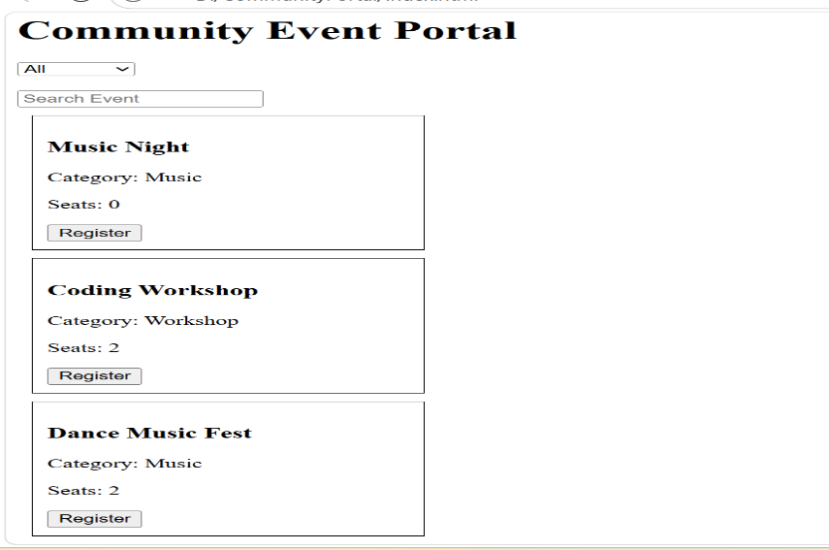
OUTPUT:

TASK 9: ASYNC JS, PROMISES, ASYNC/AWAIT
CODE:
const container = document.getElementById("eventContainer");
const loading = document.getElementById("loading");
fetch("https://jsonplaceholder.typicode.com/users")
.then(response => response.json())
.then(data => {
loading.style.display = "none";
data.slice(0,5).forEach(event => {
container.innerHTML += `
<p>${event.name}</p>`;
});
})
.catch(error => {
console.log("Error:", error);
});
async function loadEvents(){
try{
loading.style.display = "block";
const response = await fetch(
"https://jsonplaceholder.typicode.com/users");
const data = await response.json();
console.log("Async Data Loaded");
}
catch(error){
console.log(error);}
}
loadEvents();
OUTPUT:
Async Data Loaded

TASK 10: MODERN JAVASCRIPT FEATURES
CODE:
const events = [
{ name:"Music Night", category:"Music", seats:20 },
{name:"Coding Workshop", category:"Workshop", seats:15 },
{ name:"Dance Show", category:"Music", seats:10 }
];
function addEvent(
eventName = "Unknown Event",
category = "General"){
console.log(
`Event Added: ${eventName} - ${category}`
);
}
addEvent("Sports Day","Sports");
const firstEvent = events[0];
const { name, category, seats } = firstEvent;
console.log("Destructuring Output:");
console.log(name);
console.log(category);
console.log(seats);
const clonedEvents = [...events];
const musicEvents = clonedEvents.filter(
event => event.category === "Music");
console.log("Filtered Events:");
console.log(musicEvents);

OUTPUT:
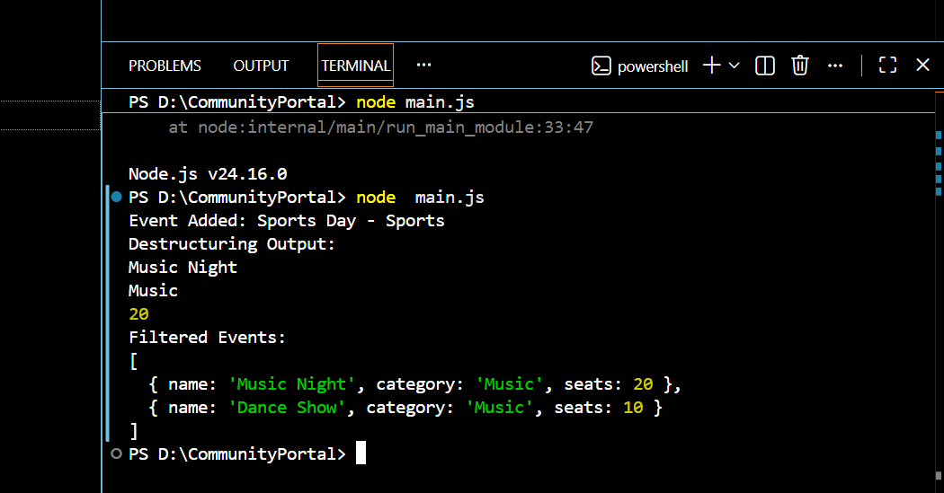

TASK 11: WORKING WITH FORMS
CODE:
const form = document.getElementById(
"registerForm");
const errorMsg = document.getElementById(
"errorMsg");
const successMsg = document.getElementById(
"successMsg");
form.addEventListener(
"submit",
function(event){
event.preventDefault();
const name = form.elements["username"].value;
const email = form.elements["email"].value;
const selectedEvent =
form.elements["event"].value;
if(name === "" || email === ""){

errorMsg.textContent =

"Please fill all fields";
successMsg.textContent = "";
return;
}
errorMsg.textContent = "";
successMsg.textContent =
`Registered ${name} for ${selectedEvent}`;
}
);
OUTPUT:
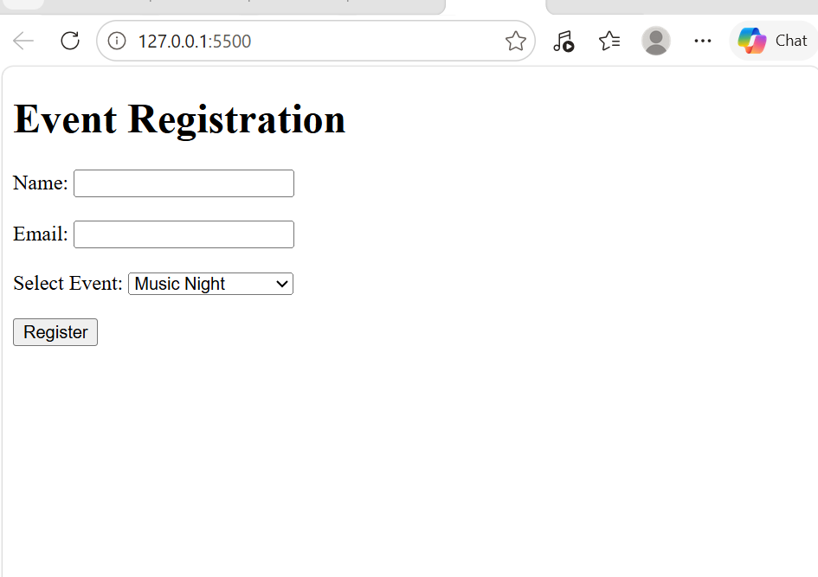

TASK 12: AJAX & Fetch API
CODE:
const userData = {
name:"John",
event:"Music Night"};
setTimeout(() => {
fetch(
"https://jsonplaceholder.typicode.com/posts",
{
method:"POST",
headers:{
"Content-Type":"application/json"
},
body: JSON.stringify(userData)}
)
.then(response => response.json())
.then(data => {
console.log(
"Registration Success");
console.log(data);
})
.catch(error => {
console.log(
"Registration Failed");});
},2000);

OUTPUT:
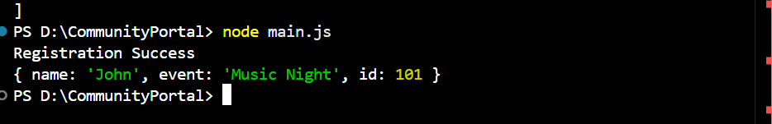

TASK 13: DEBUGGING AND TESTING
CODE:
function submitForm(){
let name = "John";
console.log(
"Step 1 Started"
);
debugger;
console.log(
"User:", name
)
}
submitForm();

OUTPUT:
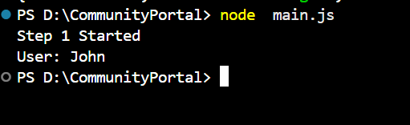

TASK 14: JQUERY AND FRAMEWORKS
CODE:
Main.js
$("#registerBtn").click(function(){
$("#card").fadeOut(1000);
$("#card").fadeIn(1000);
});
OUTPUT:
